Senior Design 2020-2021

Sidewalk Slope Monitoring System

**Task**: Web Application

**Version**: 1.0

Table of Contents

Google Maps API 3

Create Google Cloud Platform account 3

Billing account 3

Activate Google Maps JavaScript API 3

Static, Embed, and JavaScript maps 4

Map types 4

API-specific use cases 6

Use case 1: Add markers in the map for each rover image using GPS coordinates 6

Use case 2: Add markers that are in close proximity to the user’s location. 6

Use case 3: Group markers by proximity 7

API support use cases 8

Use case 1: Return the rover data for images captured in close proximity of the user’s location 8

Use case 2: Group the data for the front page map 8

Use case 3: TBD 8

# Google Maps API

## Create Google Cloud Platform account

Follow the steps below to complete the account creation process.

### Billing account

Enable the free trial that add $300 worth of credit to the billing account. A credit card is required to ensure that the user is not a robot. The credit card will not be auto charged at the end of the trial.

### Activate Google Maps JavaScript API

Visit the Google Cloud Platform home. Select the hamburger icon to open the menu. Click **APIs & Services** > **Library**.

.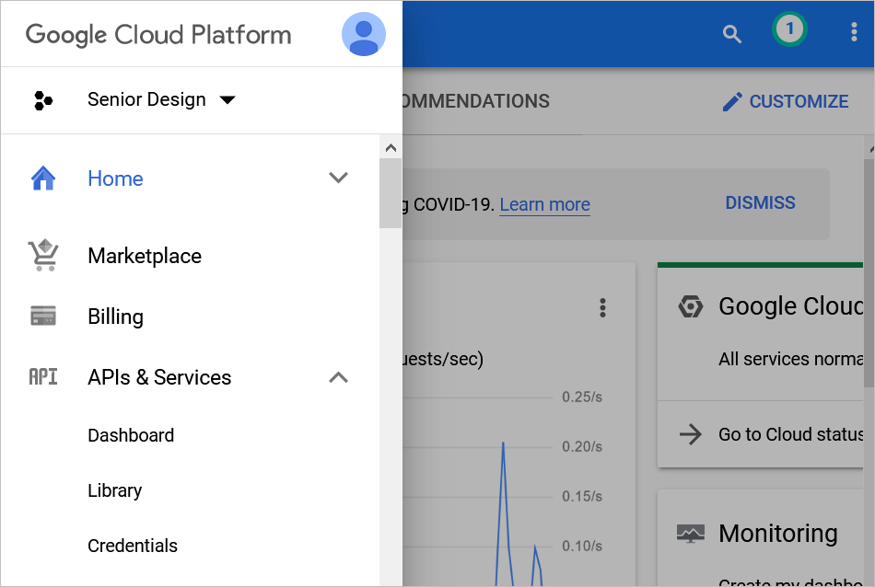

Figure 1 Google Cloud Platform home

Search for “maps” and select **Maps Embed API**, **Maps JavaScript API**, and **Maps Static API**. For each API, click enable. A green checkmark confirms it has been enabled.

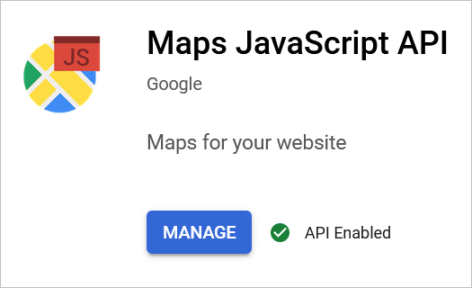

Figure 2 Enable and manage API

## Static, Embed, and JavaScript maps

The Google Maps API has various types of maps. For the testing, three types of maps were selected: static, embed, and JavaScript.

### Map types

* **Static maps** are images. Users cannot zoom in or out and are limited to the location displayed by the site.
  + <img src="https://maps.googleapis.com/maps/api/staticmap?center=Brooklyn+Bridge,New+York,NY&zoom=13&size=600x300&maptype=roadmap&key=<apikeyhere>">
* **Embed maps** are dynamic and can be controlled by the user. Users can zoom in and out, move around in the map, and change to satellite view.
  + <iframe width="600" height="450" style="border:0" loading="lazy" allowfullscreen src="https://www.google.com/maps/embed/v1/place?q=place_id:EisxMTQ5IFMgQnJvYWR3YXksIExvcyBBbmdlbGVzLCBDQSA5MDAxNSwgVVNBIlESTwo0CjIJK2YbSsnHwoAR90oe2ZB86ZkaHgsQ7sHuoQEaFAoSCZf5vkzGx8KAEReFIrIOAHKcDBD9CCoUChIJvbgjOJrJwoARd0Lt5rv7VRs&key=<apikeyhere>"></iframe>
* **JavaScript maps** are also dynamic and can be controlled by the user. Users can zoom in and out, move around in the map, and change to satellite view. This map allows for additional manipulation from a back-end perspective. We can use coordinates instead of addresses or place IDs to create a map.
  + <script async src="https://maps.googleapis.com/maps/api/js?key=<apikeyhere>&callback=initMap"> </script>

The documentation also provides generators to assist developers in creating their HTML iframes, JavaScript tags, and more. Here is an example of a generator: [JavaScript generator](https://developers.google.com/maps/documentation/javascript/overview?hl=en_US#Inline).

DOCUMENTATION: <https://developers.google.com/maps/documentation/embed/map-generator>

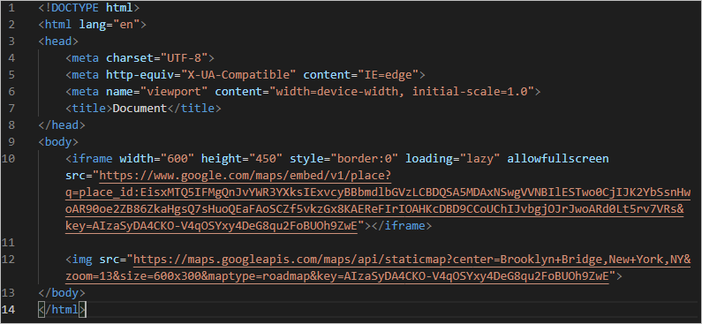

Figure 3 Snippet of code using the maps

|  |  |
| --- | --- |
| Figure 4 Static map, limited customization | Figure Embed map, zoomed out |
| Figure 6 Embed map, zoomed in | Figure 7 Embed map, using satellite and zoomed in |
| Figure 8 JavaScript map | |

## API-specific use cases

### Use case 1: Add an interactive map to each rover image page

A front page may be used to show the entire map of Los Angeles. However, for each rover image page, an interactive map must be embedded into the site.

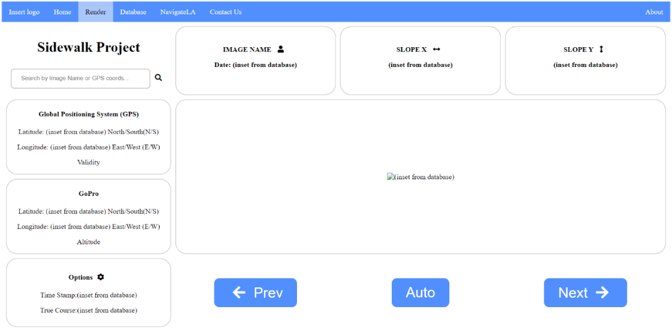

Figure Rover image page example

### Use case 1: Add markers in the map for each rover image using GPS coordinates

We can remove the point of interest markers and add markers for sidewalk segments that have images. Depending on how often the GPS coordinates change, we may need to group images. In this case, the user will be in one location in the map but can flip through the images captured at that GPS location.

TO-DO: Observe the difference in GPS coordinates. If the markers overlap due to small differences in GPS coordinates, the images need to be grouped. Otherwise, each marker represents one rover image.

DOCUMENTATION: <https://developers.google.com/maps/documentation/javascript/manage-marker-label-collisions>

|  |  |
| --- | --- |
| Figure 10 Original POI markers | Figure 11 Mockup of new markers for sidewalk data |

### Use case 2: Add markers that are in close proximity to the user’s location.

Because the map will be interactive, the user can zoom in and out of the map. In order to limit the markers in the map, only rover images captured within a certain distance (e.g. a mile) from the user’s location will be shown.

|  |  |
| --- | --- |
| Figure 12 Markers within 1 mile of the user's location | Figure 13 No limit to markers shown |

### Use case 3: Group markers by proximity

If the user wishes to see the entire map of Los Angeles, the markers can be grouped together. This could be used as the front-page map. This is meant to show a larger picture of the rover data. It will not be embedded in the rover data page.

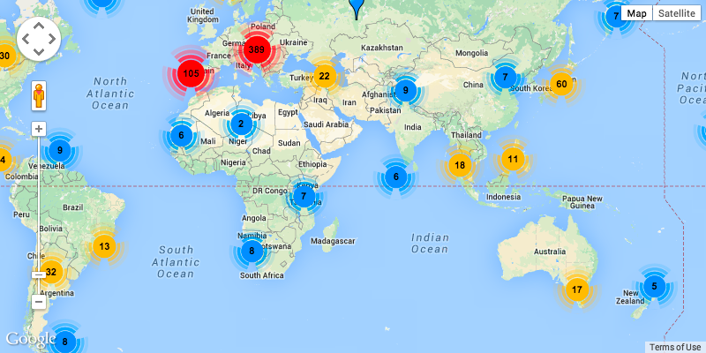

Figure 14 Example of grouping data using markers

EXAMPLE: <https://stackoverflow.com/questions/31722630/group-coordinates-by-proximity-to-each-other>

## API support use cases

### Use case 1: Return the rover data for images captured in close proximity of the user’s location

See Use case 2: Add markers that are in close proximity to the user’s location.

EXAMPLE: <https://stackoverflow.com/questions/15759518/find-proximity-distance-gps>

### Use case 2: Group the data for the front page map

See Use case 3: Group markers by proximity.

### Use case 3: TBD